Student 16
KADIRI ASMITHA
192425038
RD
4
/ 4 submitted
Level 1 — 25 marks/question
L1-Q1. (E) LCM-GCD
j
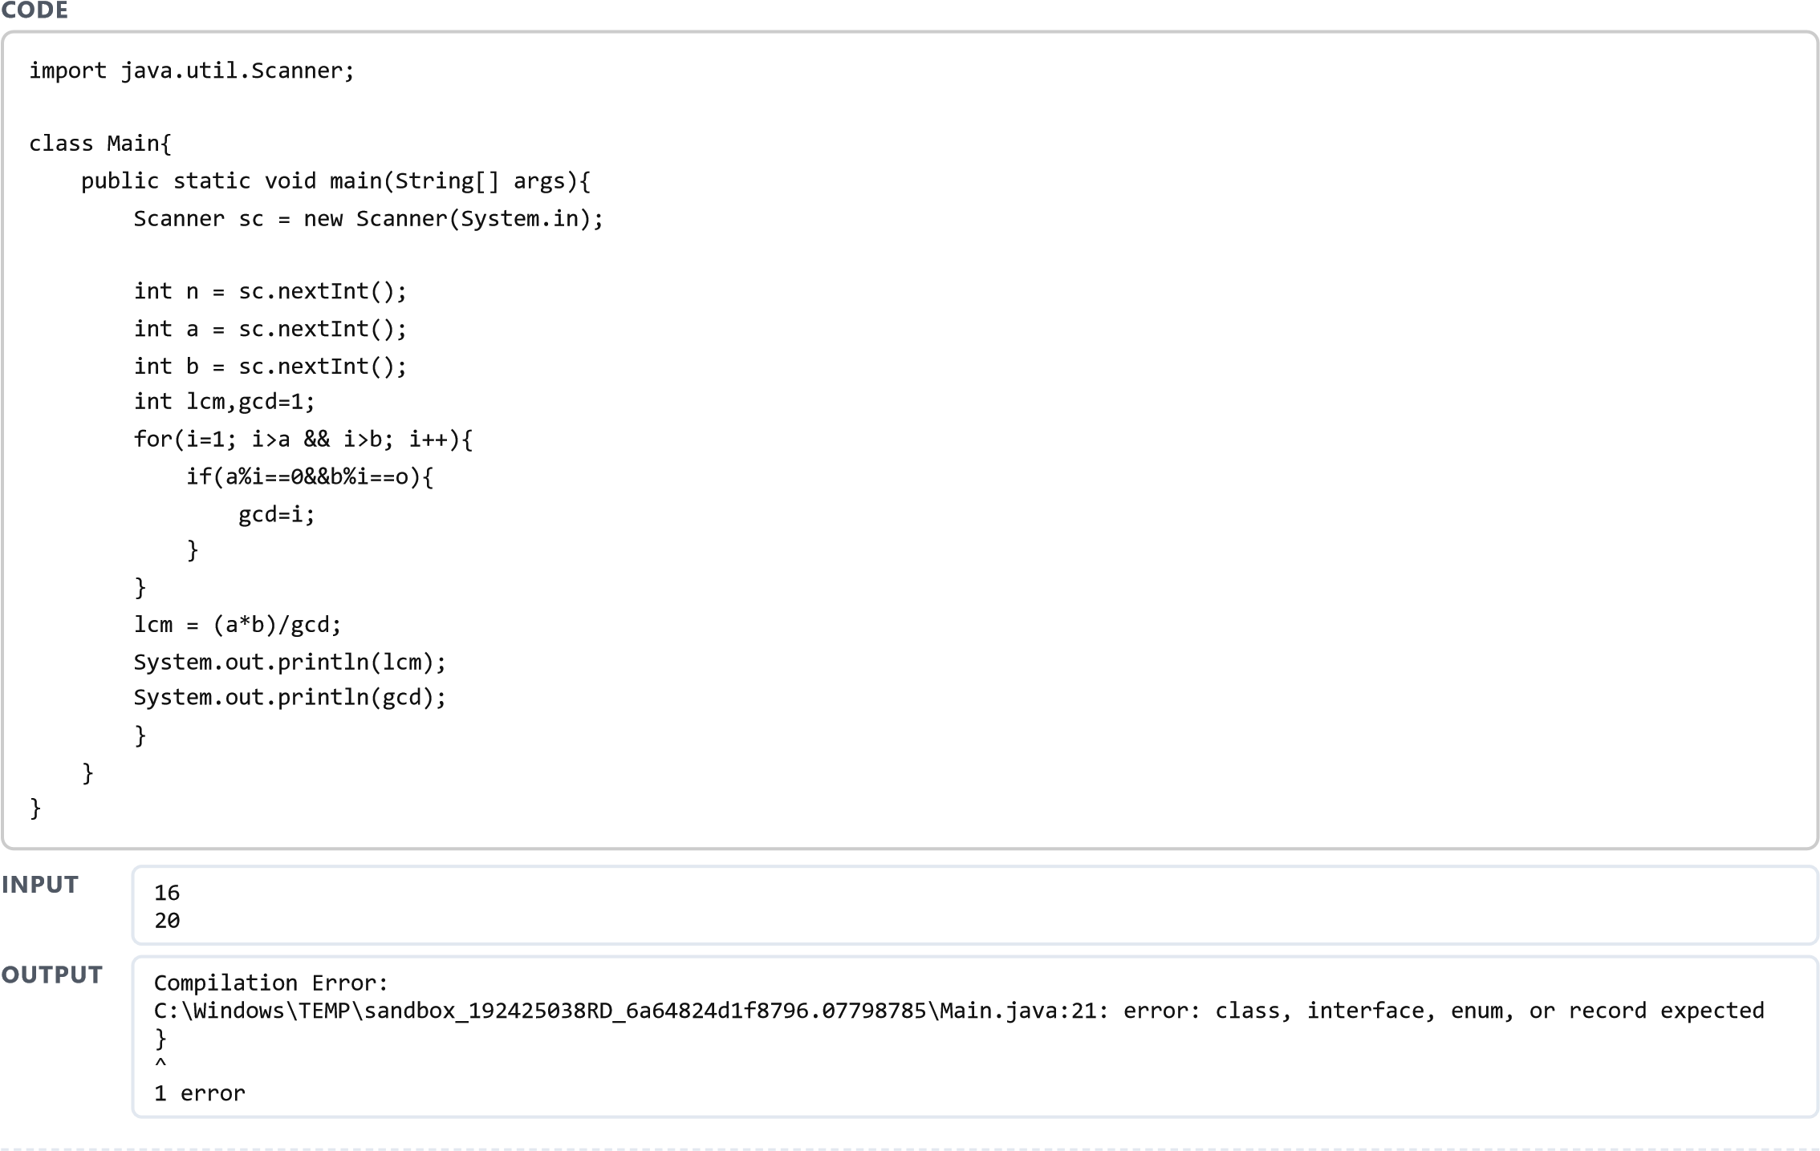
L1-Q2. (E) Right Triangle
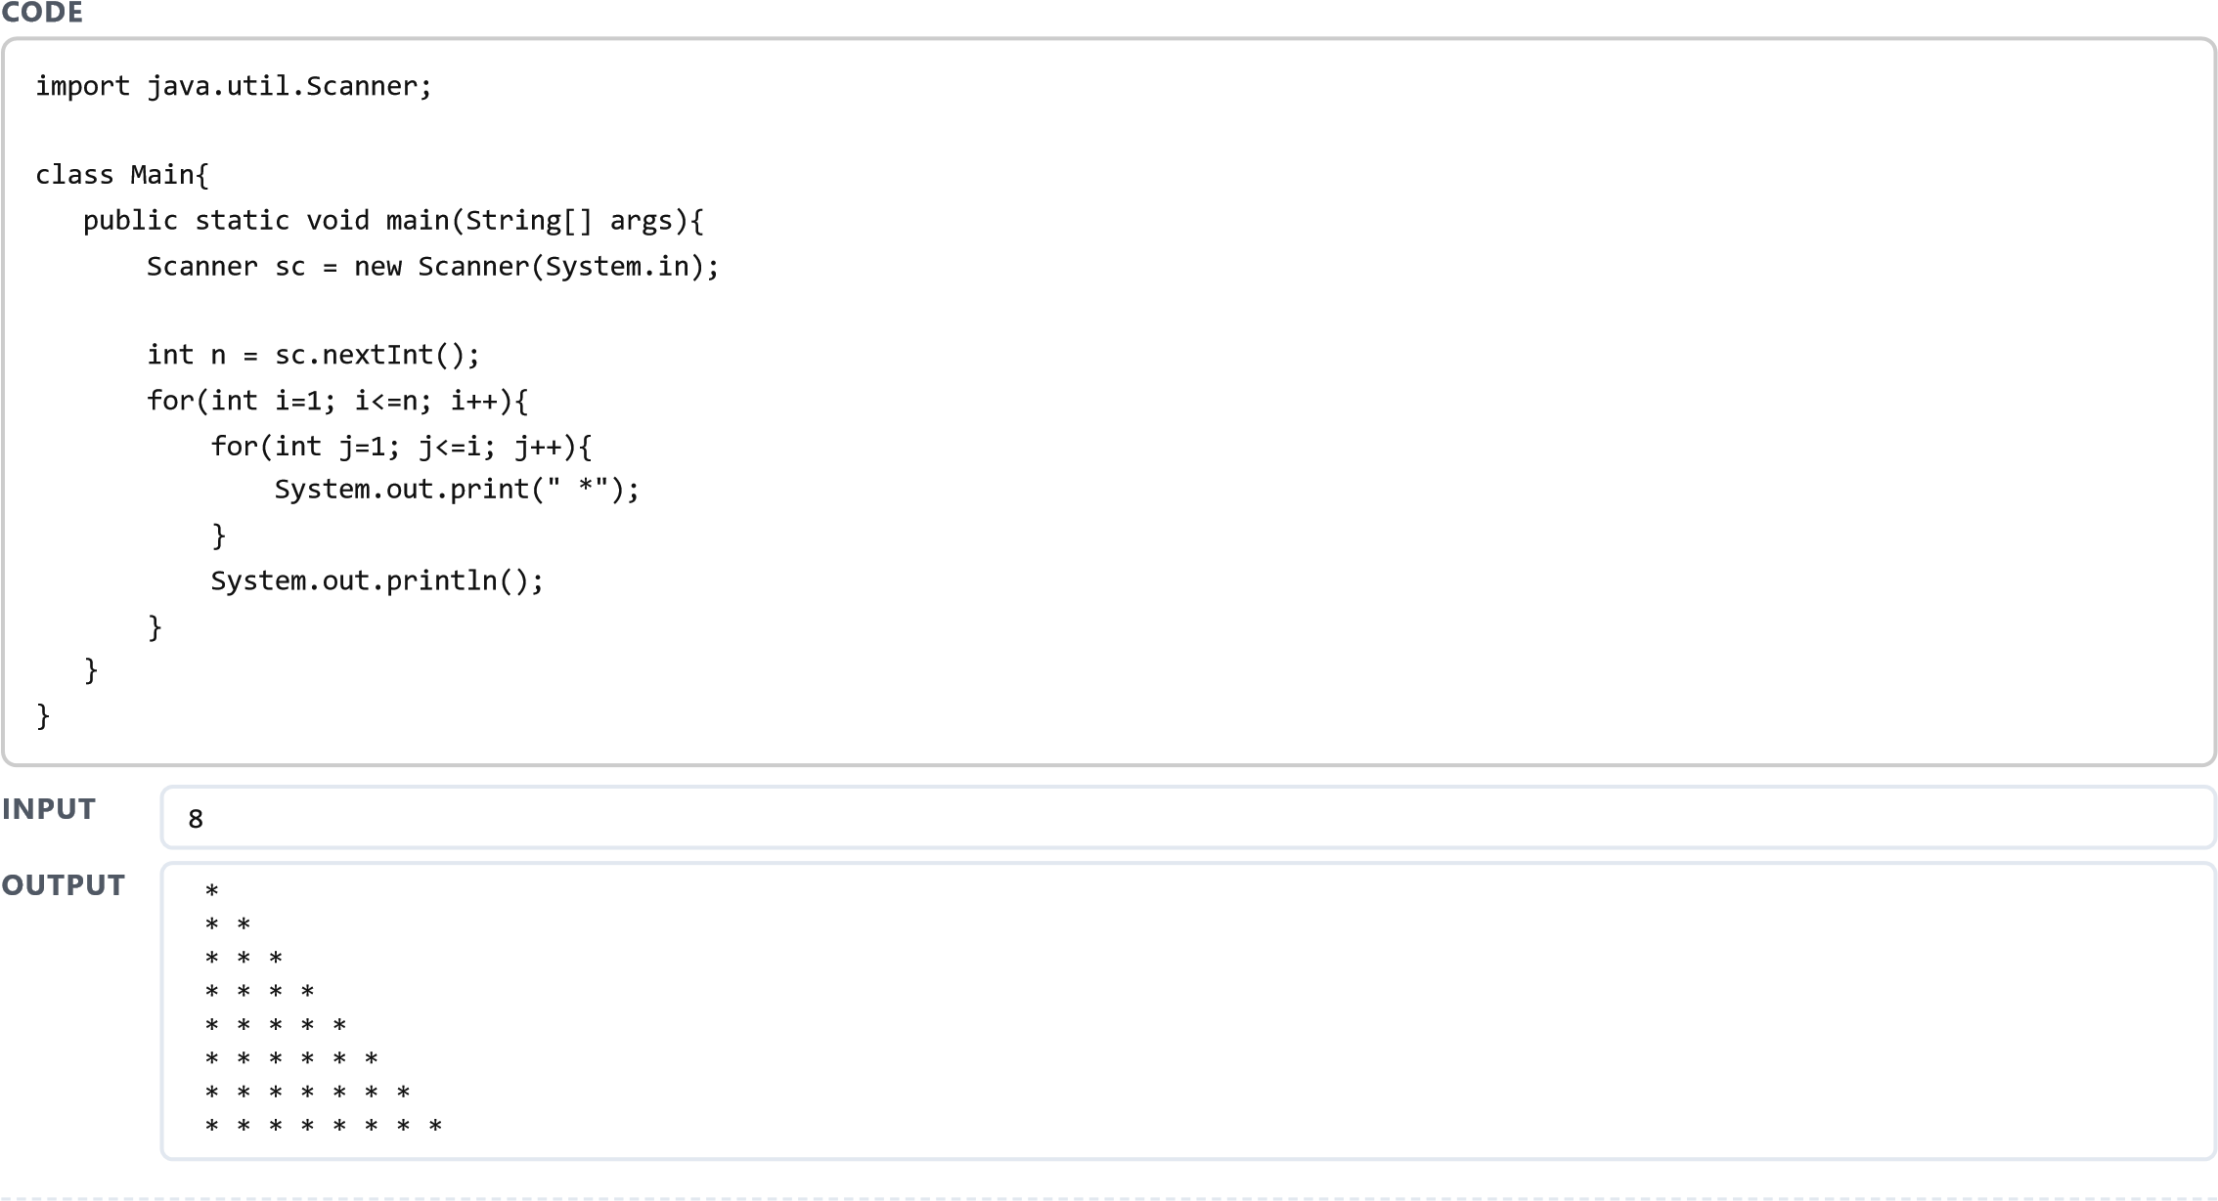
L1-Q3. (E) String Present
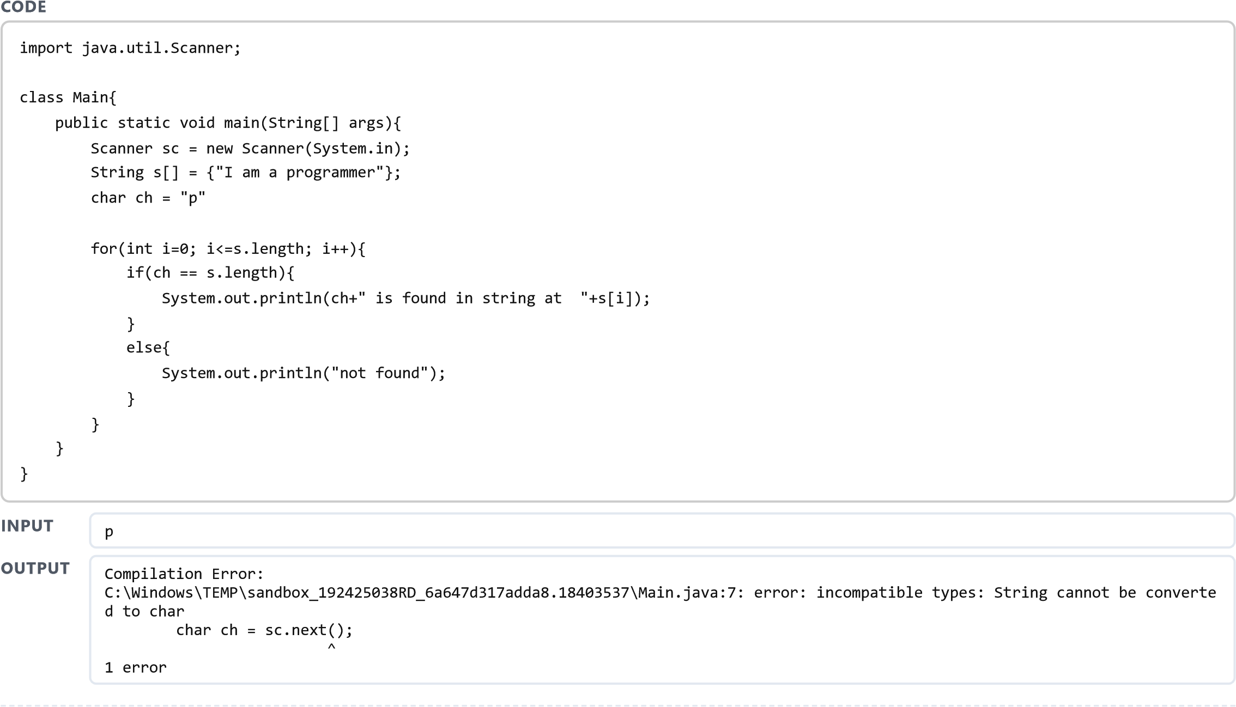j

L1-Q4. (E) Composite
j
CODE
class main{

public static void main(String[] args){

int a[]={16, 18, 27, 16, 23, 21, 19};

int count=0;

for(int i=0; i<=a.length; i++){

count++;

}

if(count > 2){

System.out.println(count);

}

}
}
OUTPUT
8

